Dipl.- Ing. Lubomír Kubelka

Personal DATA
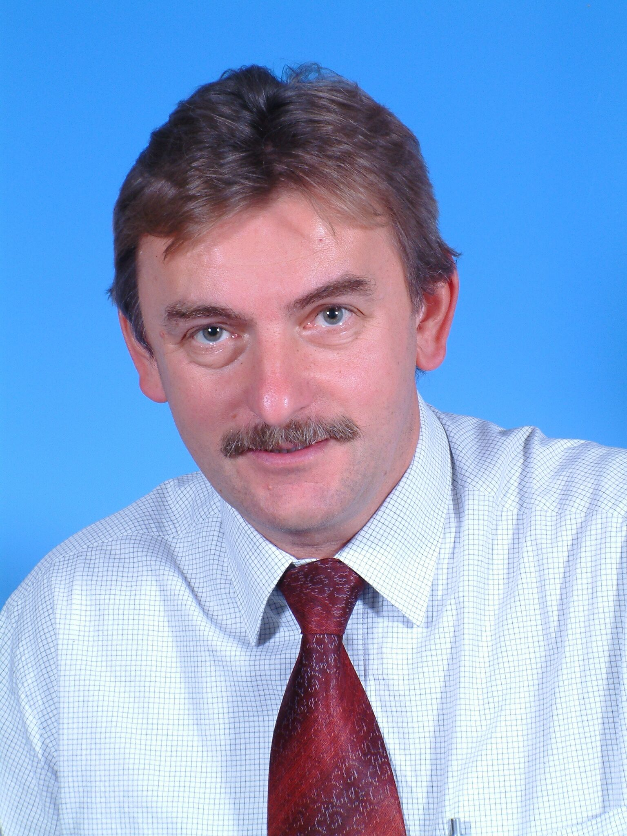Name: Dipl.-Ing. Lubomír Kubelka
Date of birth: 20.11.1955
Address: 290 01 Poděbrady, Vilová 1369/III
Period of notice: negotiation, short term

eDUCATION & tRAINING

1970 – 1974 Mechanical vocational school Chrudim
1977 – 1982 Technical University (VUT, Brno), Faculty of
Engineering
(Production technology, car design)
1985 – 1986 Professional Seminaries for mechanical engineer, Stuttgart, Germany

lANGUAGES

German (1)
English (2)
Russian (2-3)

oTHER sKILLS

- Methods Hoshin and Kaizen - professional since 1995, TQM,ZAP,EPS /5S - professional since 1996
- Production planning and implementation
- Management of production, quality and
logistic, transport management, supply chain management
- Managing JIT production, JIS,
project management, Controlling, personnel management, finances, reporting
- Knowledge of the most advanced production systems and methods in the automotive industry
- Working in an international environment

Proffesional experience

7/2010-10/2010 MEGATECH INDUSTRIES CR

This company has 3 plants MI in Hlinsko, MI in Liberec and MI in Jablonec nad Nisou (1200 employees)
Production of plastic components
Interim CEO General Manager
- Restructuring of all plants
- Implementation of control systems in Production
- Finance controlling, SAP
- Logistic, Quality etc.

6/2008-12/2009 Proseat CR, Mlada Boleslav

This company is 100% owned by Joint Venture between Recticel (Belgium) and Woodbridge (Canada). The company has two plants, one directly in ŠKODA/VW Mlada Boleslav and the other in Plazy. Production of seats, Headrests - 380 employees. Main customers, Audi, Škoda, VW, Volvo, Suzuki, TPCA, Nissan….

General Manager

Highlights:
- Increasing the productivity from 4.7 to 12
- Reducing scrap from 3.5%/turnover to 0.5
- Reducing conversion costs for one product
- from 6.89 EUR to 3.7 EUR/per FBE
- Increasing operating results: 2008 producing 3.4 Mio seats ,
- 2009: by reduction of volumes to 2.4 Mio seats (AUTOMOTIVE production dropping about 30% ) ,
- (operating result increasing to 150 Mio CZK).
- RFT (right first time) increasing from 43% to 89 %
- Absenteeism reduction 7% to 2,9%
- Reduction downtime Line from 6% to 2,8%
- Reduction of Non Quality Costs from 6 Mio CZK to 1,5 Mio CZK
- Cost Reduction Program 2009 – Saving ca.1,8 Mio EUR

2004 – 2008 MCA Management consulting automotive
General Manager
- Restructuring of companies
- Production transfer (machinery and automotive)
- Optimalisation of the production
- Implementation modern processes (KAIZEN, 5S,
Hoshin), Coaching of managers
- Logistic concepts, strategic purchasing etc.)
- Responsible for results and budget
- Main Customer – Projects – Greenfield project new
Plant in Janovice CR (250 employees) 2004-2006
OLHO-TECHNIK CZ (Germany company) for Plastic
Components – Cars – SKODA, VW, FORD, BMW...

2002 - 2004 UVMV Prague - TÜV SüddEUTSCHLAND
Motor Vehicle Research Institute Ltd. TÜV AUTOMOTIVE. This company is testing cars for car producers SKODA,VW ,AUDI, (passive security, crash-test, crash-airbag, homologation, motor-testing, component homologation and testing etc. (250 employees)
General Manager

      - Consolidation the organization
- Increasing the productivity
- Getting new customers and projects
- Getting back the confidence of SKODA/VW,AUDI,
BMW……
- Modernizing the equipment
- Implementation effective test procedures
- Increasing the image of the company
- Responsible for results and budget
- Reconstruction of Crash Labors for Car Testing

2000 – 2002 MCA Management consulting automotive
General Manager
- Projects - Restructuring of companies
- Production transfer (automotive)
- Optimization of the production
- Implementation modern processes (KAIZEN, 5S,
Hoshin, KANBAN
- Logistic concepts, strategic purchasing etc.)
- Responsible for results and budget
- Restructuring of KAUTEX-Textron CR company
- Customers – Projects – New Greenfield Project ITT
Automotive (Germany) for VW – SKODA, Production
of Break Components for SKODA-VW, AUDI, SEAT, DAIMLER ….
- OLHO-Technik CZ Production of Plastic Components
for SKODA-VW, AUDI, SEAT, DAIMLER, FORD, BMW…

1996 – 2000 SAS Autosystemtechnik, Mlada Boleslav
This company was 100% owned by Joint Venture between FAURECIA (France) and SIEMENS (Germany). The company has two plants in ŠKODA VW Mlada Boleslav and ŠKODA Vrchlabí. The company is an integrated fractal supplier of Cockpits for A4/ŠKODA OCTAVIA in ŠKODA-VW Mlada Boleslav (400 employees).
General Manager
- Responsible for the Project management of the OCTAVIA A4 cockpits in co-operation with SKODA and VW.
- Cooperation in the design of assembly lines
- Responsible for building up the complete infrastructure (personnel, logistics, equipment)
- Implementing production methods
- Certification VDA 6.1
- Budget and financing
- Negotiations with SKODA/VW
- Introducing modern methods of lean-management and EDP-documented production and quality systems (all production processes are controlled and monitored on-line, the results are documented on CD)
Highlights:
- He became one of the first fractal managers in the history of the automotive industry.
- In 09/1996, short after the establishment of the company, it was awarded the Price of Quality (Q-forms) in SKODA-Auto and VW Group.
- Because of good quality, the most advanced production system and an excellent reputation in SKODA/VW the company received other contracts for Audi A3, Renault Megane in VW Brasil, Cockpit – Polo GP in VW Spain etc.
- The knowledge and technical development designed in SAS Mlada Boleslav is used in other SKODA, VW plants.

1994 - 1996 Magna stamping CR, Praha
This Canadian company was a supplier of automotive equipment. The company produced stamping parts for BMW, SKODA-VW, AUD, 300 employees...
Manager of Production and Logistics Planning
- Responsible for transfer of production from BMW-Germany to the Czech Republic
- Planning and managing of production, investment planning.
- Organization of transport management, production,
- Stock management and supply of equipment to BMW, ŠKODA, VW

1986 - 1994 sulzer-escher wyss, Ravensburg (Germany)
This company (4500 employees) designs, develops and produces turbo- machines and power plants for ships, etc..
Production and Planning Engineer
    - Responsible for planning of production processes
    - Selection of manufacturing technologies
    - Analyses of production budgets, CNC, production, consulting

1984 - 1985 kloos, Weingarten (Germany)
This develops and produces different tools for the automotive industry. The company is a supplier to Daimler Benz, BMW, Opel, VW. Design and Development Engineer: Design and development of machinery and equipment for the automotive industry

1983 - 1984 Knabe, Weingarten (Germany)
This company is a producer of assembly lines for the automotive industry. Design and Development Engineer: Design of assembly lines for the automotive industry, Project management

1983 - 1984 tESLA pŘELOUČ CR: Production Assistant

1974 - 1977 ČKD Praha CR: Production Technologist

Profil DescrIPTION
I graduated at the Technical University in Brno, Faculty of Engineering (Production technology, car design). I started my professional career in the production in CKD, one of the former largest Czech producers of heavy machinery products and equipment’s and TESLA, a producer of electro technical equipment.

In 1983 I immigrated to Germany, where I started a new career within a producer of technological equipment for the automotive Industry, ships and power plants. In these companies I worked in different technical positions as a design and development engineer and production and planning engineer.
After returning to the Czech Republic, I started with Magna Stamping (Canada) in Prague, where I was responsible for the production transfer from BMW and the production. In my next position I became a General Manager to start the production at the first fractal-integrated automotive supplier within VW/SKODA. Afterwards I worked as a General Manager in different automotive related companies.
I have focused on automotive industry even during my studies and therefore I have complex overview regarding this industry. My strong points are long-term practical experiencies within the automotive industry, strong leadership skills and a sound economic awareness. I have also very good overview over all advanced procedures used today as best practice within automotive industry. My capability is to implement, improve and innovation all processes to reach the best solutions and increase economics results. My next important strong point is my long-term good relationships with Škoda Auto, VW, BMW and many automotive suppliers. I take part very often as a speaker of important AUTOMOTIVE seminars and meetings.

